**NATIONAL UNIVERSITY OF COMPUTER AND EMERGING SCIENCES**

**(KARACHI CAMPUS)**

**FAST School of Computing**

**Spring 2024**

**Course:** Software Engineering (CS3009)

**Course Instructor:** Ms. Javeria Farooq

**Project Name**: Restaurant Food Ordering App

**Project Milestone**: Prototype

**Team Members:**

21K-3279 Insha Javed

21K-4503 Muhammad Tahir

21K-3317 Naqeeb Nadir

21K-4606 Sabika Shameel

**Technology:**

* NextJs
* Bootstrap
* Tailwind CSS
* React

**HOME PAGE**

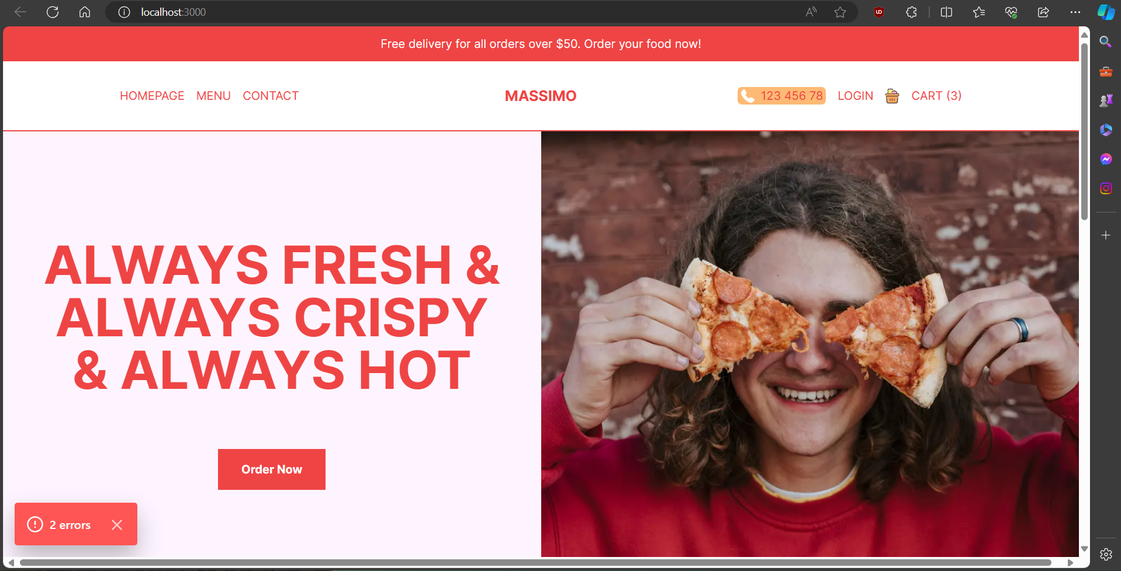

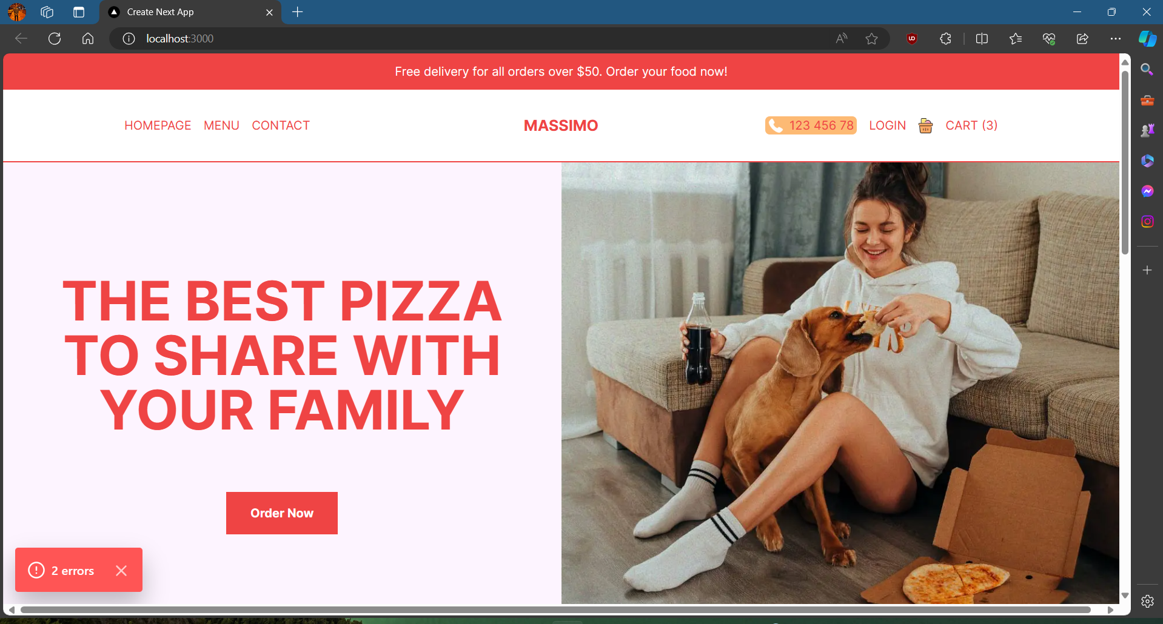

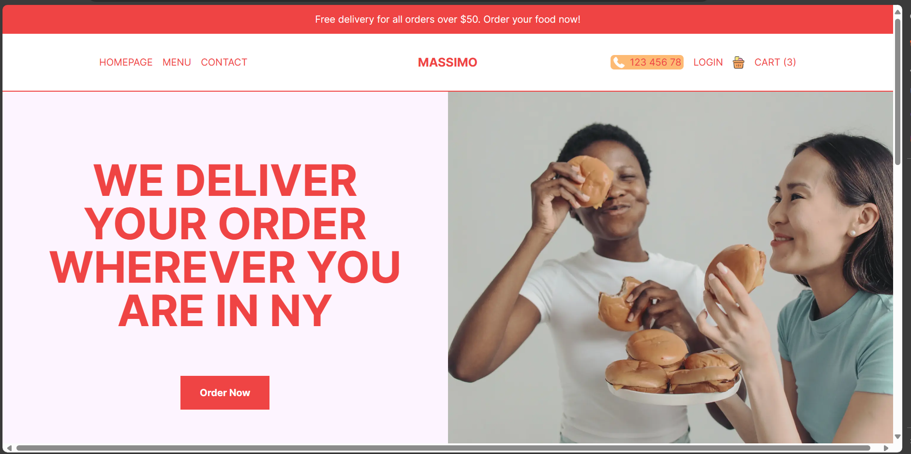

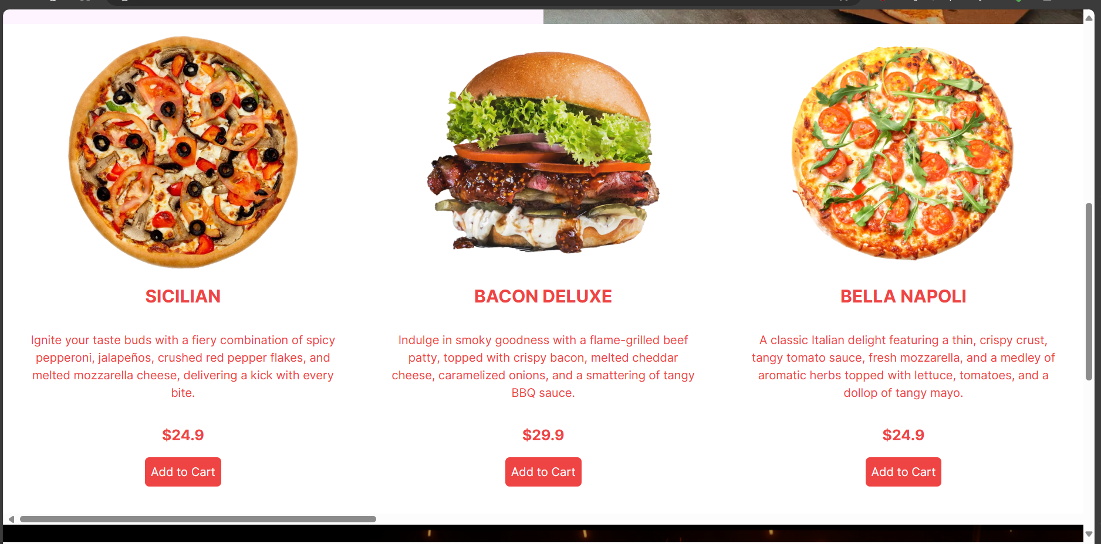

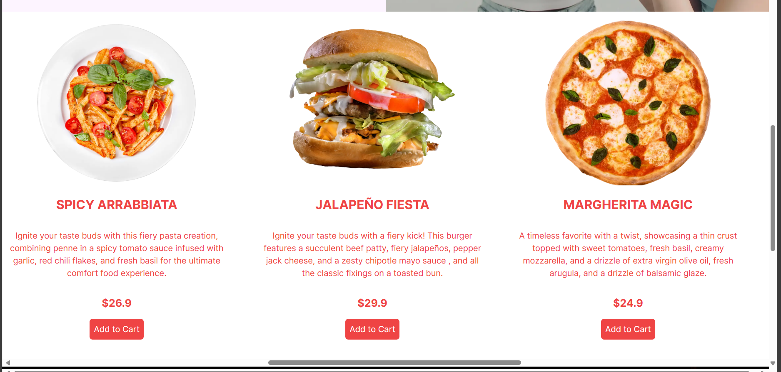

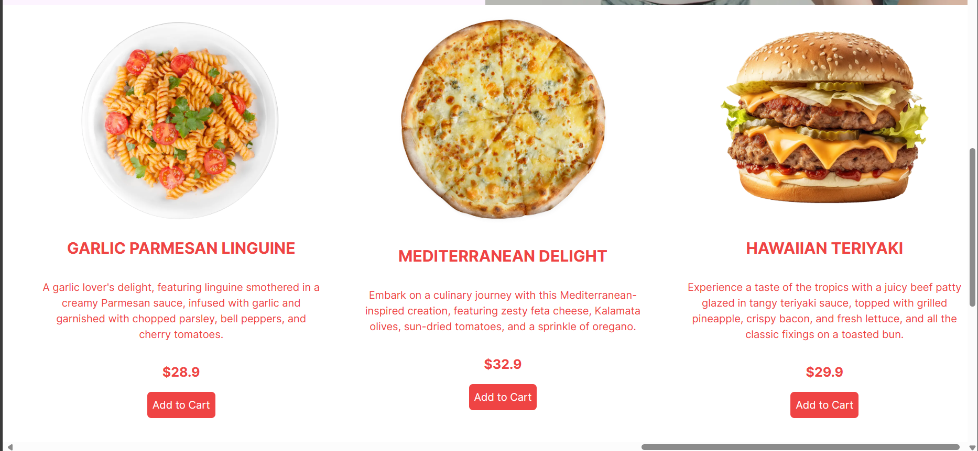

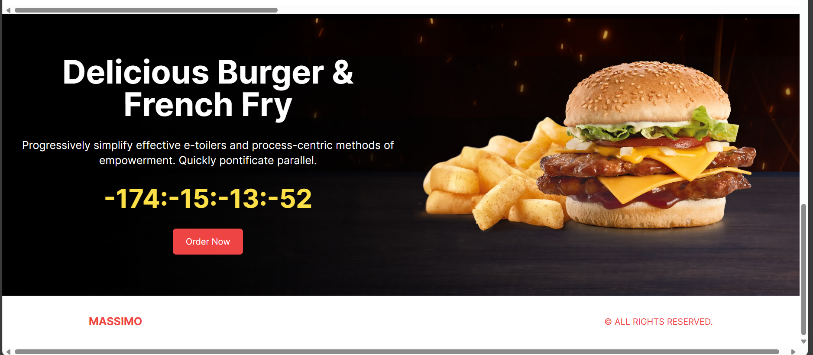

**LOGIN PAGE**

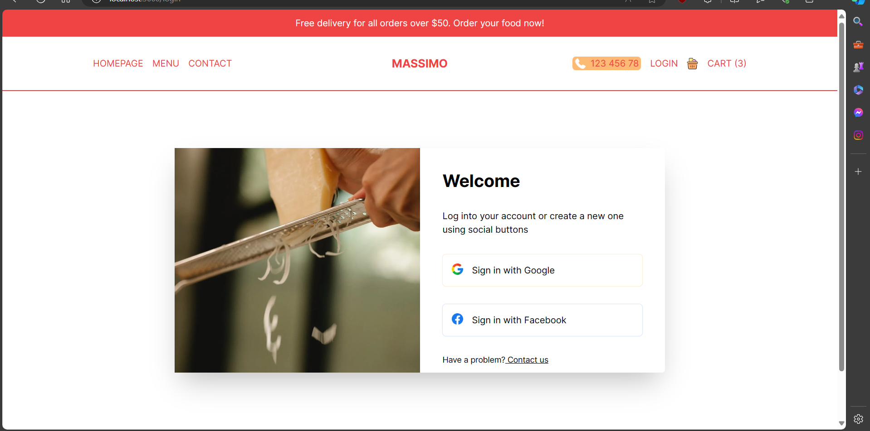

**MENU PAGE:**

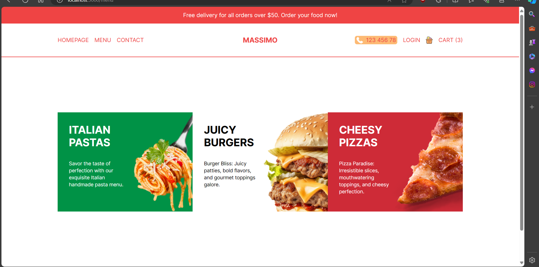

**FIRST OPTION (ITALIAN PASTAS)**

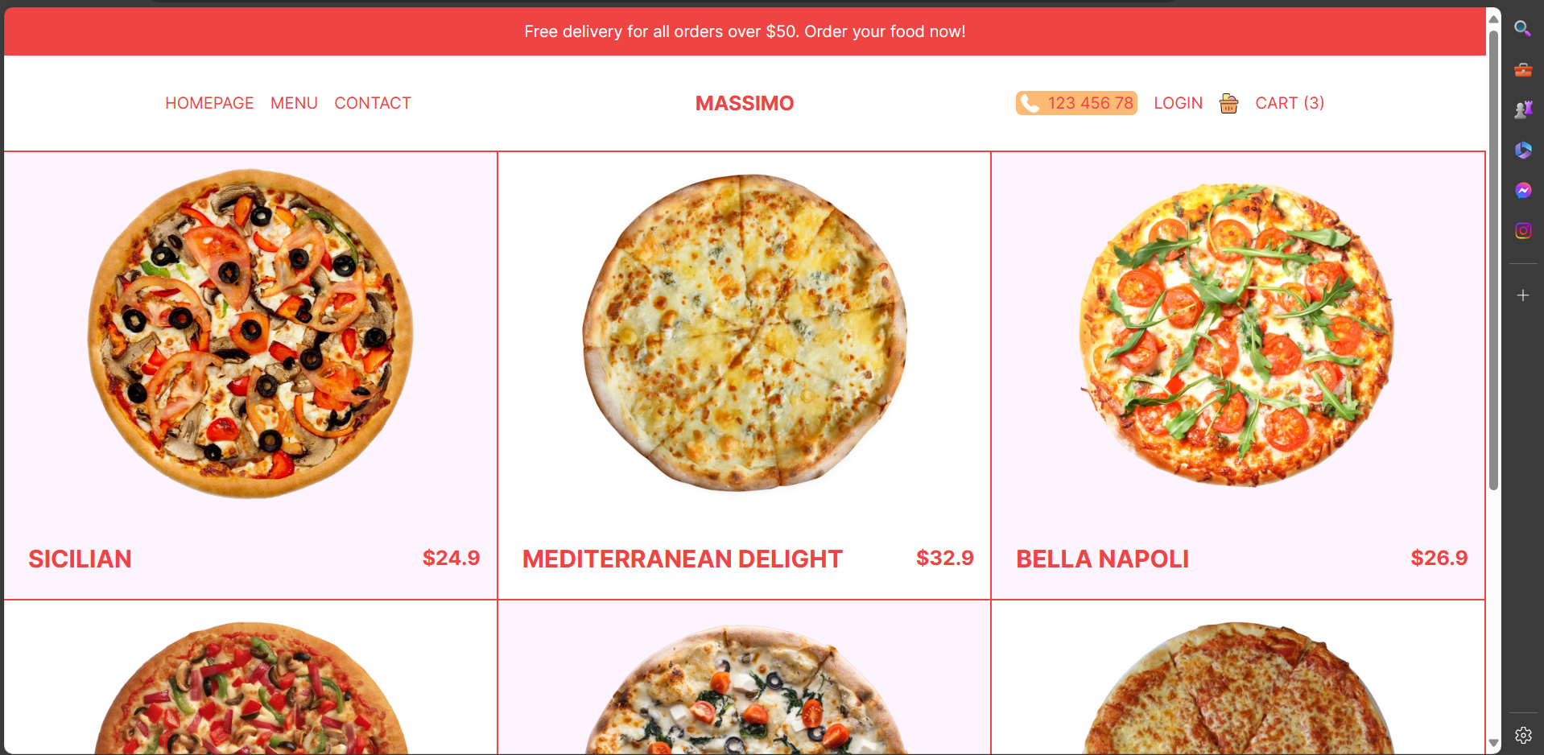

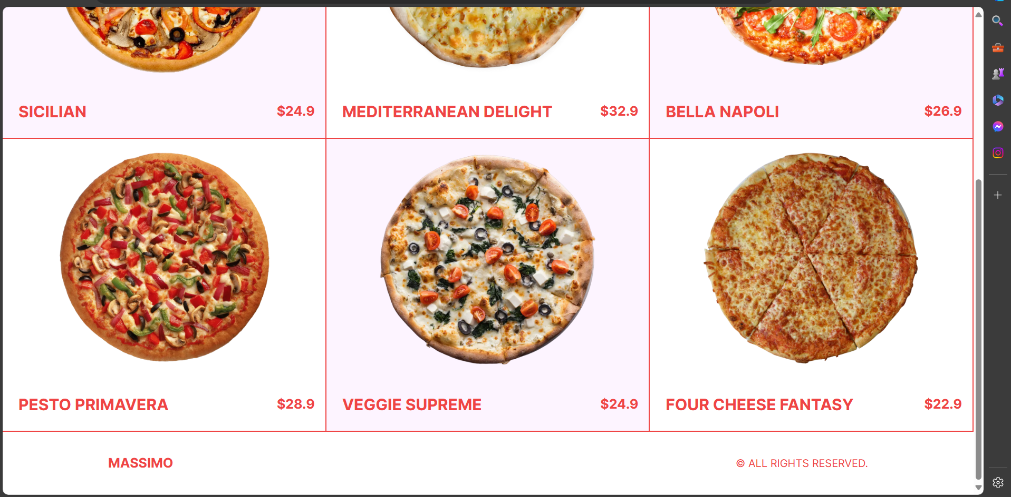

**SECOND OPTION (JUICY BURGERS)**

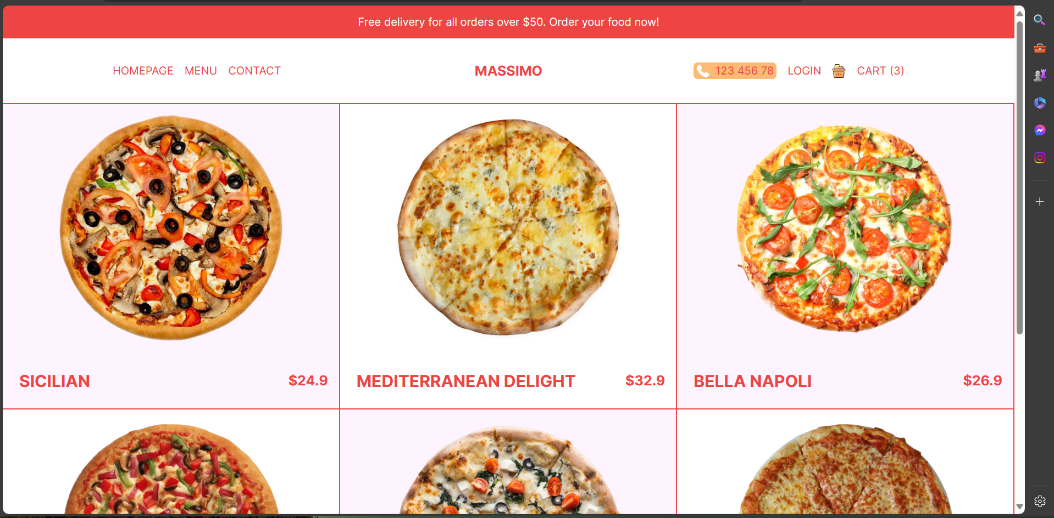

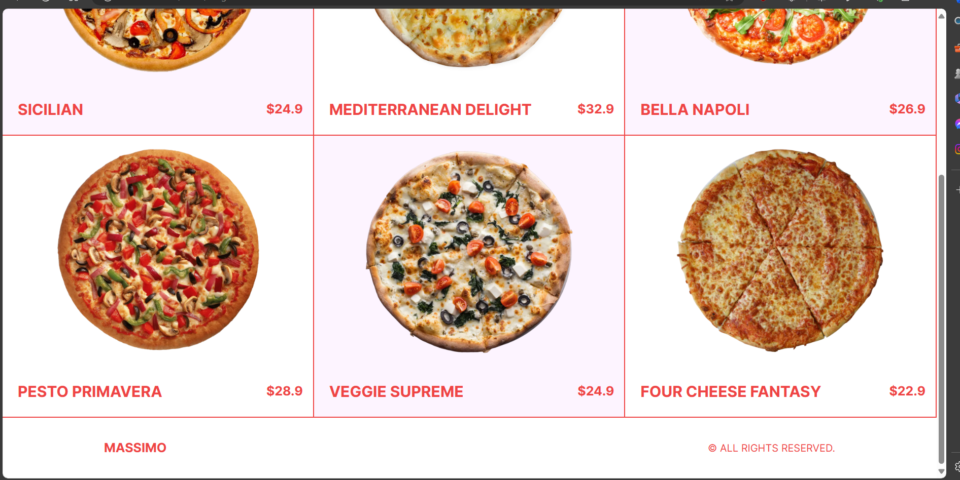

**THIRD OPTION (CHEESY PIZZAS)**

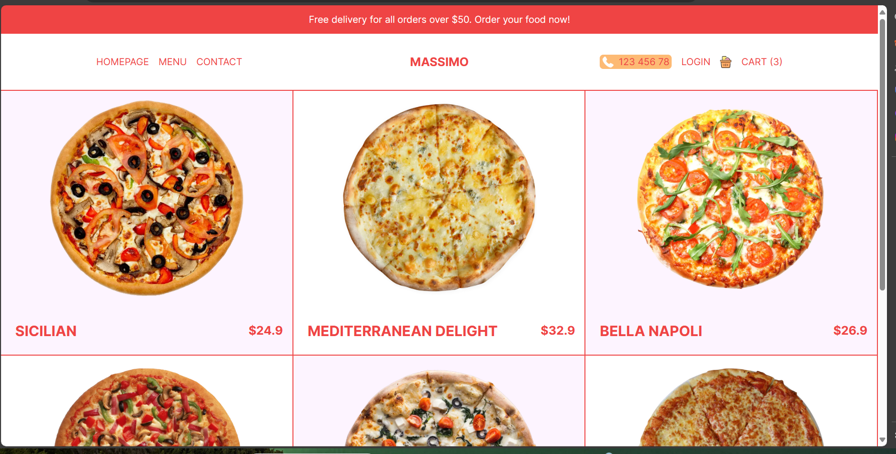

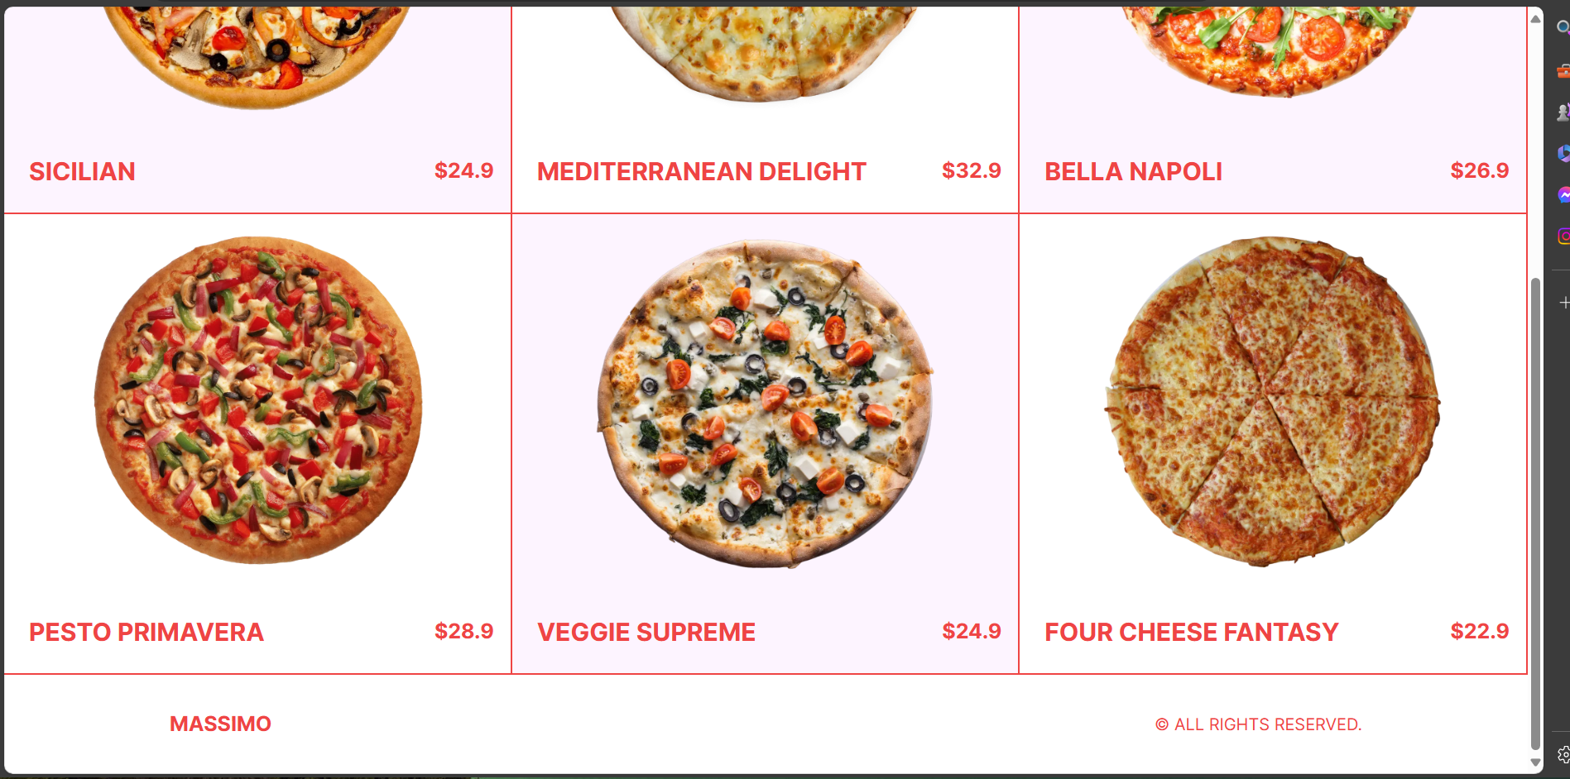

**CART PAGE:**

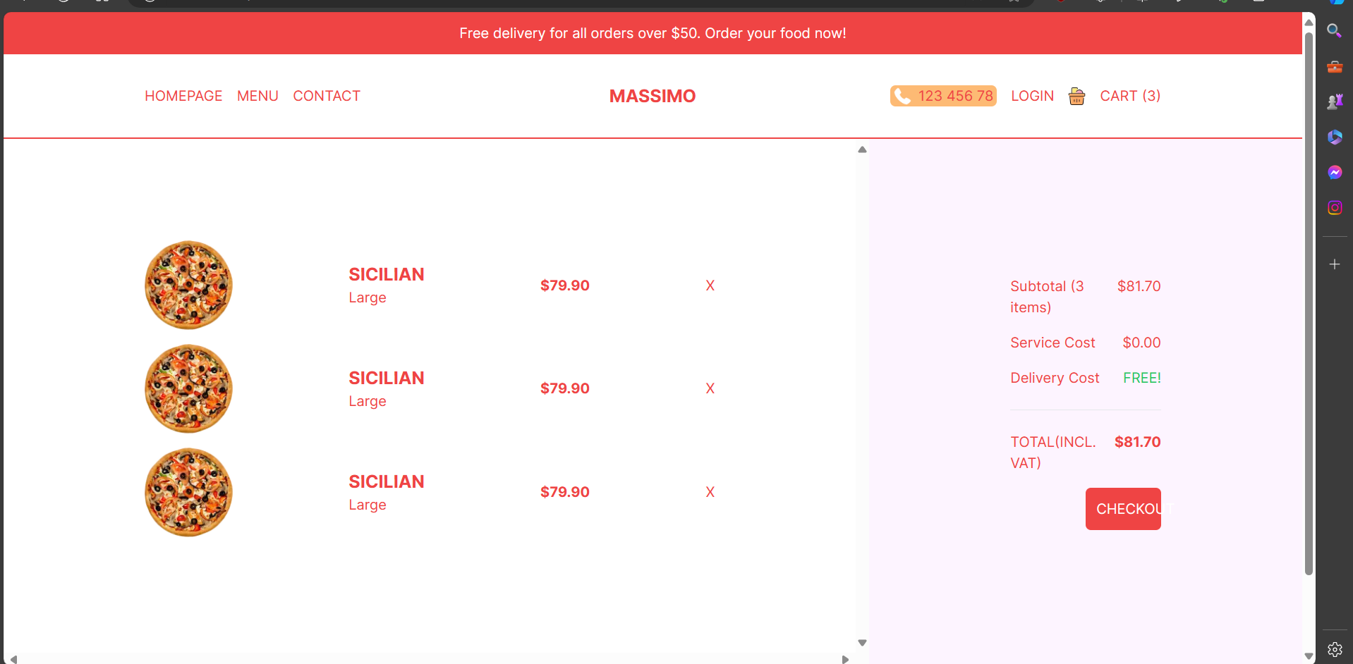

**VIEW ORDERS:**

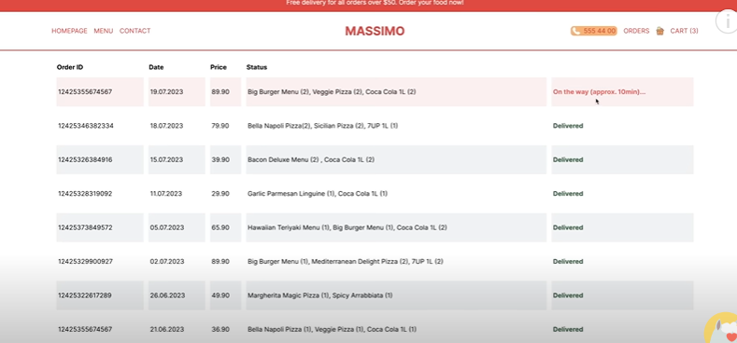

**GET CREDIT CARD CREDENTIALS:**

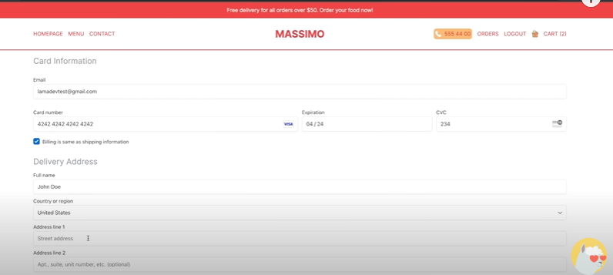

**ADD PRODUCTS:**

